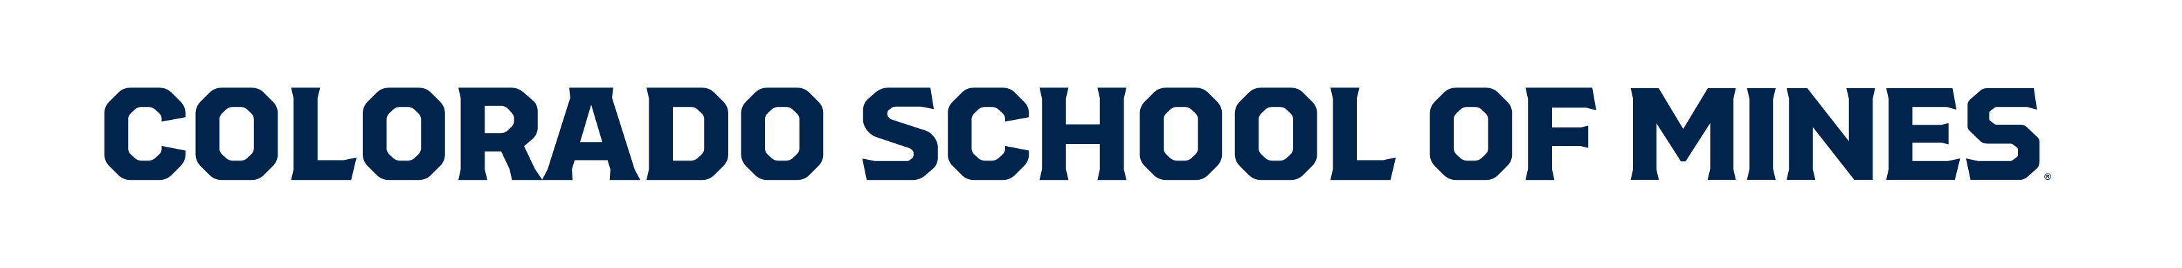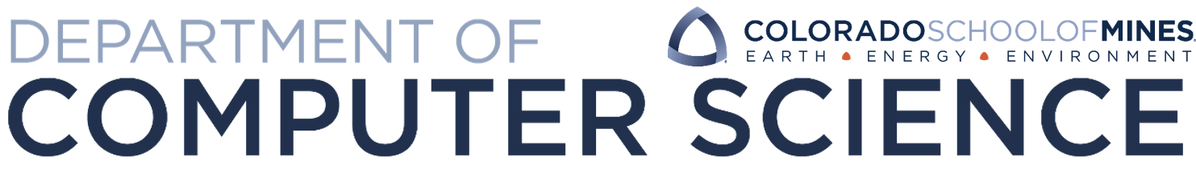

Certificate of PARTICIPATION



This certifies that

[Student Name]

has participated in the CS@Mines High School Programming Competition

on April 29th, 2023

Presented by:

